Magic Invitational: Kai Budde
Kai Budde
'Click'
Wow, what great name for a report, eh?
I guess that is what you are thinking right now. But that 'click' was by far the most important thing that happened to me in Sydney.
But before I come to that you'll have to get through the rest as well...
When I learned that I was voted into the Invitational (thanks to everyone who voted for me!) in Sydney, I was thrilled. Six months ago, I played my first Invitational in Kuala Lumpur, Malaysia and I really enjoyed that.
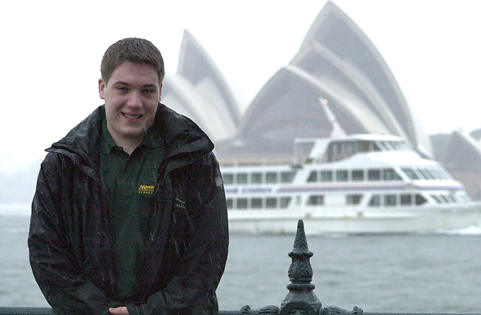
I had always wanted to go to Australia, as it is one of the most distant places from Germany. They had the Olympics a couple of months before I would get there. That didn't make things worse.
Only Gary Wise and I wanted or had time to go to Sydney early. After my flight from Hamburg to London was cancelled and I spent 10 lovely hours playtesting Standard (which would later pay off) with the royal real tennis teacher Ben Ronaldson at the Hampton Court Palace in London, I finally got my connection to Sydney. I got there on Saturday and the Invitational was scheduled to start on Wednesday we had two days to do a little sightseeing. Unfortunately, I brought the weather from northern Germany to Australia and starting Monday it rained a LOT. We couldn't really do anything outside and so we went to watch a PTQ for PT-Tokyo. When I got there, I recognized a familiar face and looked it up at the pairing. I was right and Stefan Krings, a friend that used to play local tourneys in NRW (area of Germany where I lived until 2 months ago), was playing in the PTQ in Sydney! At times, you get the feeling that the world is REALLY small. Unfortunately, Stefan lost in the quarterfinals of the PTQ to Kim Brebach with his Sliver horde, who went on to make Top 8 in the GP.
The event came closer and it became apparent that neither I or Gary did sufficient testing. I was pretty set on my Type I deck, which was Necro/Donate with just one Necro, one Bargain, lots of restricted cards and every card drawer availble along with 4 copies of the most broken utility ever, Duress and Force of Will.
I played only a few games of block and chose to go with a Squirrel/Opposition/Tradewind-design that should theoretically beat red decks (Elder, Hermit, Bottle Gnomes, Chills), which I expected to turn up a lot.
Going into the tourney, I really wanted to do well. I became very disappointed with my finishes lately as I failed to make Day 2 at THREE Limited Grand Prix in a row. Also my Worlds showing was rather poor and I barely made Top 64 in NY with what I felt was the best Rebel deck around (teammates finished 2nd, 3rd, 5th, 17th, 19th, 25th, 32nd - 12 out of 14 people playing it made money). With no really good finish in the last eight months or so, I had to prove to myself that I still deserved that slot in the Invitational.
After we took some cute pictures on Wednesday under a bridge and everyone got soaked while doing so, the tourney started with Duplicate Sealed on Thursday.

Format 1: Duplicate Limited
Looking at the cards, I felt that there were some really savage combos in there. The creatures, on their own, were just too bad, so I built my deck Goblin Bombardment as there were a lot of silly combos possible (specically Living Plane). I used green as almost everyone else did (the green creatures were very good) and chose to run a splash of black for the Banishing and the Tutor along with the Stairwell.
My first round opponent was Gerardo Godinez. He was playing GRB as well. I can't remember how I lost the first game, but the second one was a savage beating. I let him go first and he went turn 2 Wild Mammoth, turn 4 Hunting Moa and my first spell, a turn 5 Maro, met his Bone Shredder on turn 6.
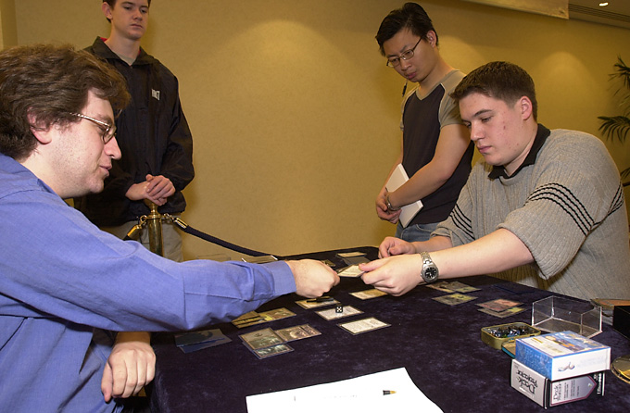
Alex Shvartsman was my second opponent. I have to remind you here that Duplicate Limited is an extremely slow format. Everything is at least 4-5 to cast, usually more and a lot of the spells require two colored mana. In BOTH games Alex discarded on turn 3 or 4! In the first game, I dropped a turn 5 6/6 Maro. Unfortunately, some higher authority seemed to think that it was about time for someone to scream "Holy Pikula!" once again as I did NOT win those games! In the first game, I was holding SIX lands when I dropped that Maro and Alex drew into more lands, Banished the Maro and dropped creatures. While I continued to do what Alex did - drawing more lands ... I died with 12 lands and 4 spells I think. In the second game, my land/spell-ratio was very similar and despite discarding in both games, Alex swept me...
Next in line was Dave Price. He was going for the WG beatdown deck, while no one else got even the idea to play beatdown given the card pool!!
First game, he dropped some creatures, attacked and when I foolishly went down 10 life or so, he used Berserk and Explosive Growth to kill me...
Even though he was playing the beats, I let him start in the second game, as there were no real beats I thought. He started with turn 2 Wild Mammoth and Empyrial Armored it on turn 4! Of course, my first spell on turn 4 was a Spidersilk Armor, followed by a Rukh Egg on turn 5, which was really amazing as I had to gain control of that monstrous Mammoth on Dave's side. Dave didn't attack on his 6th turn and played a Herald of Serra. I dropped another Hill Giant for six mana and passed the turn. Dave paid echo, drew and played a land. I used Bone Shredder on his Herald and passed the turn. His Mammoth deserted to me during his upkeep. When he passed it over the table he was laughing and said that about nothing could save him at this point (him: 7 lands in play, 1 more in hand, me 3 creatures in play, a couple of cards in hand). His mammoth had brought me to 2 life though. So Dave drew, naturally, the Triskelion, which was now 8 mana to cast.
So my first mark on the mission to prove to myself that I could still play this game was a sweet 0-3, 0-6 in Duplicate Limited.
Bring Your Own Block was the second format and I felt quite confident there as most players were talking about red beats and my board had Chills along with Bottle Gnomes and UG control should have a decent shot at beating that deck anyway. This is what I choose to play:
Kai Budde Hermit-Opposition
TE-UY-UD
Main Deck |  | Sideboard
16 Forest  8 Island  4 Rofellos, Llanowar Emissary  4 Deranged Hermit  4 Yavimaya Elder  3 Masticore  4 Heart Warden  4 Tradewind Rider | 3 Plow Under  3 Miscalculation  3 Treachery  4 Opposition | 1 Treachery  1 Plow Under  4 Bottle Gnomes  2 Tranquility  1 Harmonic Convergence  2 Splinter  1 Masticore  3 Chill
I was pretty sure that my first opponent would play Tradewind/Awakening as it was Zvi Mowshowitz, who said that he didn't really test as well and he did quite well with that deck last year. I really didn't like that matchup, as we were both playing control-decks only that he had more powerful spells (countermagic, Whipsers, Capsize) in the control-matchup. I got crushed by Awakening in the first game, won the second with a very good draw and got a turn 3 Opposition with a Heart Warden and later a Rofellos in play in game 3. Zvi got only three blue mana, which meant that for about three turns I could cast whatever I wanted. I drew my second and third Opposition and my second and third Rofellos! (Finally Zvi started casting stuff and one turn too late my Deranged Hermit came up. One turn earlier, and I could've locked him, but by now a Tradewind would be active next turn and an Awakening entered play soon after.
Noah Boeken was my fifth matchup. As expected, he brought a Sligh/Ponza-deck with him. He won the coin toss and went first. On his fourth turn I died to double Reckless Abandon and Fireblast! I boarded about 8 cards. Now I had fourteen 2 drops and eight 3 drops to stop his assault. My opening hand, had none of those 24 cards. I mulliganed into 5 lands and a Tradewind Rider!
I kept that as I didn't want to go to 5 cards. My turn 4 Tradewind was my first and last spell of the match.
0-5, 1-10. I was asking myself why I took that 40 hour flight? To see a rainy city? Not a big difference from Hamburg. To get smashed game after game? That happens in the local shop a lot too.
I woke up the next day, determined to finally win a match ...
My last match of BYOB was against Chris Pikula. He was playing Darwin Kastle's Survival-deck. I lost the first, played Rofellos, Plow Under, Opposition, Tradewind, Hermit in that order in game 2 and lost to bad mana draws in the third.
Ah, 0-6. At least I won another game!
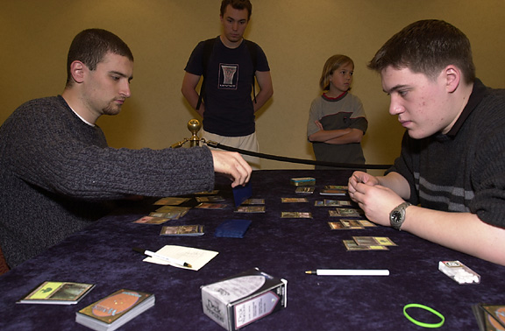
The third format was Solomon draft. I already missed the bye in that format (playing Pikula, who always loses at Solomon) and I was sitting down with Jon Finkel for the first Solomon draft. The first pack showed that this draft was all about gold cards. Jon and I were both drafting quite defensively. The only difference was that Jon was smart and I was dumb. There were so many quality cards in so many different colors that Jon quickly realized that everyone would get more then enough cards to build a deck with. But the way we were drafting meant that we probably had to use all five colors. So he sacrificed a little bit of power and drafted the mana fixers. In the end, we both were five colors, I had the better cards and he had 7 of the 10 available Cameos/Duals. Needless to say, I watched in both games Jon playing his spells while mine were sitting in my hand.

If I wanted to come back, it would be by riding Dragons to victory...
My next opponent was Ben Rubin and this time the theme of the draft was Legends. There were three important cards, Sisay, Empress Galina and Tsabo Tavoc. Sisay was the worst of them and Tsabo the most powerful, as it has protection from Legends and can be dropped even after Galina became active. I ended up GRB, with the Harrow and a Sol Grail to fix the mana. I also had a Breath of Darigaaz and a Dark Banishing, plus Tsabo for removal. Ben was WGU with Sisay, Galina and Barrin. Both games were less than noteworthy: Even though I had Tsabo and 2 removal for her, Empress Galina entered play in both games and got active. I didn't draw any of my three cards that could possibly help me there and got destroyed.
For some reason 0-8 felt rather bad.
Yoshikazu Ishii was my ninth opponent. This draft was all about the Invasion-Djinns and protection and stuff to change colors like Whim of Volrath and Blind Seer. Unfortunately, Yoshikazu apparently didn't listen when Maro announced that and build a pretty good GRW beatdown deck with lots of cheap guys. That made me leave all of the cool color stuff in the board and I had to try to mount some sort of early defense. I knew that I should win the late game as I got a lot of powerful stuff like Tsabo's Assassin and Karmic Guide while he was running mostly small guys.
First game he just overwhelmed me and a Knight of Dawn finished me off with the protection ability. I won the second game on the strength of his pretty weak draw. The third game looked bad right from the beginning. I had three lands in my initial hand and only 5CC stuff and up. But I was going second and I didn't really want to mulligan that hand. I was pretty much all set to discard from turn 4 on as it would have happened in all the matches before this one.
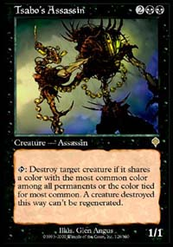
But this time it was different. My first draw was the Tsabo's Assassin. On my third draw I drew a 3 drop and my 4th and 5th turns brought me the lands to cast my guys. Against Rubin, Tsabo herself couldn't help me, but her Assassin was beating Ishii senseless. Even though I had a great start, my life went into single digits quite fast. But after the Assassin got tapped 5 times, it was all but over. AND I FINALLY WON A MATCH!
Before that game, I was in a really bad mood and felt almost like I couldn't win anymore. But when I won that third game it 'clicked' in my head, I went to bed no longer that frustrated, looking forward for the last six rounds where I needed at least a 5-1 in order to not finish last. And I was determined to put up a fight at least.
The first format of the last day (well at least the last day for me!) was the Auction of Champions. On the flight to Sydney I thought about which deck I wanted and what I would bid for each of them. But now at 1-8 I was determined to pick up my deck. It served me so well at Worlds giving me extraordinary draws and I was sure that if I wanted to come back, it would be by riding Dragons to victory.
During the auction I did some biding on some decks but I would never bid in a way that I might get a deck, and if I would it would be at ridiculous conditions. When finally my deck came up I started bidding and when my bid of 6 cards (initial hand) and 20 life came around, everybody sat down!
Being 1-8, I was set on 6-0'ing the last day, so that it wasn't a complete disaster for myself. After eight of my first nine opponents crushed me, I got ready to send some Dragons into the Red Zone.
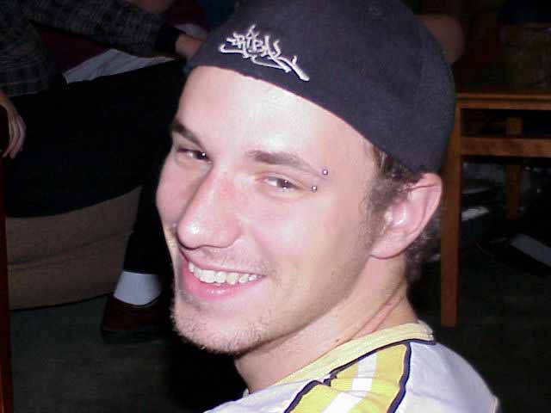
Ryan Fuller
My first round was against Ryan Fuller who had Paul McCabe's Necro-control. The really scary part was that he had Rituals and Disks and the fourth Necro in the board. The first game was over by turn five. I dropped turn 1 Grim Monolith, followed by turn 2 Thran Dynamo and turn 3 Karn. I attacked with the Dynamo on the turn I dropped Karn, made Ryan's Zuran Orb a mighty 0/0 guy and with Ryan already starting with a low life total, he never had a chance to come back.
The second game saw Ryan start with a Ritual-Hypnotic Specter-draw. I dropped Mountain-Cursed Scroll and peeled enough lands from the top of my deck to kill the Specter turn 3. Next turn I dropped a Masticore with one card in hand. Ryan was holding a Stupor, but Core/Scroll reduced him from 15 to 0 before he ever saw that third land.
2-8, 5 to go.
Up next was the second Canadian, Gary Wise. He was running Randy Buehler's Necro deck. I felt I had a huge advantage here as he had no Disks and access to only three Disenchants after boarding. Except for 1 Ihsan's Shade, his only ways to kill me were 8 pump knights which didn't stand much of a chance between my Wildfires, Scrolls, Cores and Quakes from the board. Gary got less then mediocre draws too and I swept.
3-8, 4 to go.
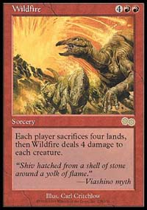
My last opponent was Dawin Kastle. He was 2-0 in the auction too. When Mark said that we were playing, I was all jumping. Darwin was running nothing else then Olle Rade's mighty spider.dec from Columbus! Spider for 3, Core for 4, sounds very reasonable! Also Olle was running very few lands, so I knew that after a Wildfire he should not be able to come back.
When we played exactly that happened. When he tapped 4 lands and his Elf on turn 4 to cast Deadly Insect, I wiped away his side of the board. The 2nd game saw me playing another Wildfire and after he put up some savage resistance with 1 land and his sideboarded Icy Manipulator in play while I was activating three Apertures a TURN, I finally found some fat, red, flying guys ....
4-8, 3 to go.
Next up was Type I. I was really confident, because I liked my deck a lot.
My first opponent was Mike Long. He was running a mainly blue control deck with Fact of Fiction. First game, I got a nice draw with Force and Duress backup, dropped Necro and took him out. The second game saw me with a mediocre draw and him with a Gorilla Shaman, which wrecked me. In the third game, Mike used Amnesia on me which I Pyro'ed. He Forced and we both had empty hands now. I drew nothing and passed the turn. He drew Merchant Scroll, fetched Ancestral, played it and gave me the turn. I drew Yawgmoth's Bargain, cursed that I drew it right after he got three extra cards. I played it nonetheless, Mike's jaw dropped, he said ok and got off to watch some other matches and 5 minutes later I told him that he just lost 20 life.
5-8, 2 to go.
Trevor Blackwell was next in line. He was running a version of Channel-Torch with some early beats and the Power 9. He went first in game 1 and opened with Tropical Island. I proceeded to have one of the most amazing Type I draws ever. I dropped a land, Mox, Mox, Mana Vault and Mind Twisted trevor for 4. He used Mystical Tutor to fetch Ancestral in response, shuffled his hand and discarded down to one card. He gestured towards untapping his Tropical but I had something else to play. I dropped Black Lotus, added BBB and played Necropotence. After drawing fifteen cards, I Forced his Ancestral and killed him turn three.
Second game was not much better for him as I got Bargain in play, used Abeyance to get around his Pyroblast, dropped Illusions, drew 20 cards, Donated and Pyro'ed them right away.
6-8, almost done.
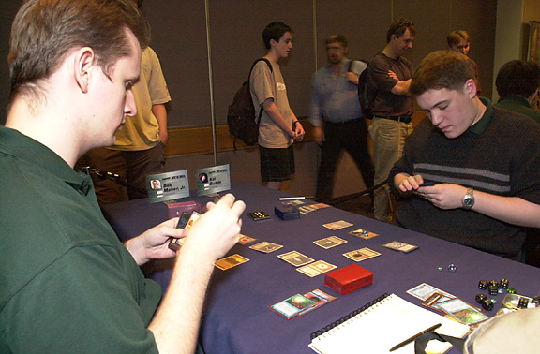
The last person who could stop my run was Bob Maher. He was playing a 5C-control-deck. First game, I got out Necro but he had Seal of Cleansing in play (I playtested with my deck earlier so a Seal found the way into his maindeck after he knew that he would play me in Type I). I dropped Bargain and untapped. Then I Abeyanced him. He Vampiric Tutored in response and I let it resolve. As soon as he drew the card, he started to get visibly upset with himself but I had no idea what it was. I dropped Illusions, drew 20 cards of the Bargain, Donated and Pyro'ed, all under the Abeyance. He cursed and flipped over the Obliterate that was on top of his deck! If he had Sealed my Bargain in response to the Abeyance all I could do was to play Illusions, draw 15 cards with the Bargain, set up a hand of a couple of Force of Wills and say go. He would untap, cast Obliterate and I would die to my own Illusions!! Sometimes you got to get lucky to win.
Next game, Bob absolutely crushed me with Gorilla Shaman. The third looked also really bad for me. He had an early Twister with some Moxes in play and had a permanent advantage of four or so. I couldn't really do anything but Twister myself, with him still having a huge advantage on the table. On his turn he played a land and said go with 7 cards in hand. I had nothing but 1 Bargain and 1 Pyro vs. his seven cards. I dropped it, he looked at me and said, in a not very happy voice, "Sure!" I had to control myself in order not to laugh, drew some cards and killed Bob who showed me the 7 lands that he drew off the Twister afterwards!
7-8, mission accomplished!
Was I relieved! At 0-8, I was thinking about quitting the game as I was so depressed. After I 6-0'ed the last day, my mood was a LOT better. I did make quite a few screw ups during the tourney, the draft vs. Jon, when I didn't realize that it was all about the mana and something vs. Ben which I can't really think of any longer but I made some mistake when we played it out there. But after a perfect 6-0 in the last two formats, my world was all right again. Of course, I had hoped to make the finals, but when you are 0-8, you just want to get out of the whole mess with a reasonable result, which I luckily managed to do.
I have to give some props at this point:
- Ben Seck, Rod Ho and Simon for showing us Sydney and being all around good guys
- Mark Rosewater for inventing the Invitational and running it really great both times I attended
- Gary Wise for being generally good times
- Sydney when it doesn't rain, I saw tons of great postcards which showed a very beautiful city
Slops go to:
- a group of random Americans (Mr. Rubin is on top of this one without a doubt) who wanted to see 'Gladiator' over and over again on the hotel TV while playing cards; I think I saw that movie about 15 times there
- British Airways for showing only one movie on the flight back from Sydney - GLADIATOR!
- Chris Pikula: 0-10 in Solomon lifetime!!

